**FINANCIAL POWER OF ATTORNEY FORM**

**Duration**

This Power of Attorney Form will start on Thursday, August 12, 2021 and will end on Saturday, August 13, 2022.

**Revocation**

Once it ended, this grant will be revoked. This document can be revoke immediately or anytime once the Principal created or requested for a revocation form.

**Governing Law**

This Power of Attorney Form shall be governed under the laws of Idaho.

**Signature**

We, the undersigned, hereby agreed that we have read this agreement and bounded by its terms and conditions.

**Principal's Signature**

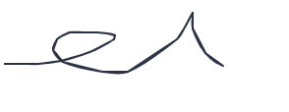

**Attorney-in-Fact's Signature**

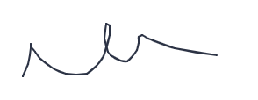

**Date Signed**

August 13, 2021

**Date Signed**

August 13, 2021